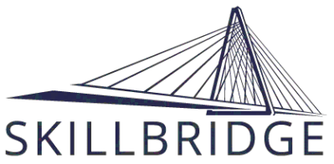
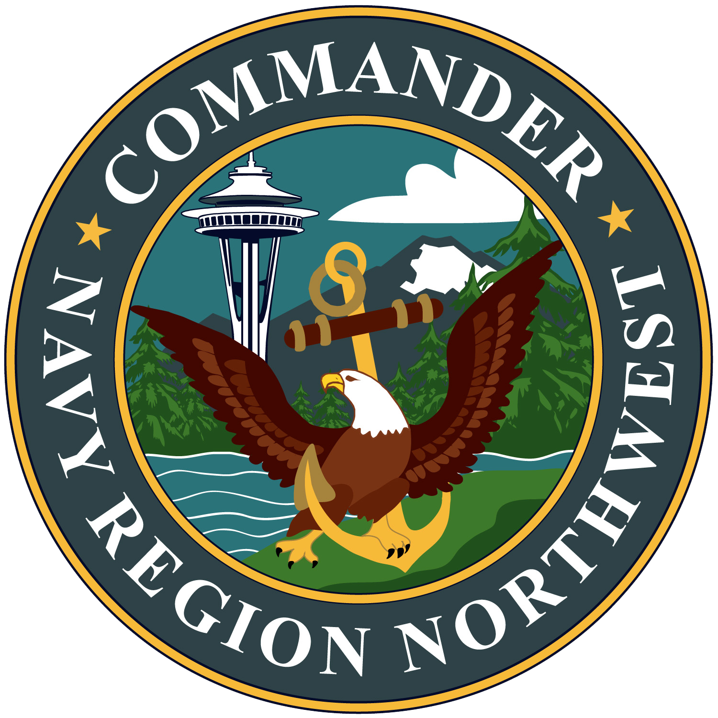
PARTICIPANT SKILLBRIDGE SUBMISSION PACKAGE
CHECKLIST

☐Cover Letter-(Optional)
Explain What you are requesting and include list of supporting materials enclosed

☐ Instruction
- DoDi 1322.39
- NAVADMIN 222/15

☐ NRNW Skillbridge Application
☐Eligibility Criteria Documentation (Show proof as outlined in the
NAVADMIN)

☐Training program Materials
- (Program Flyer, Employer Information, Training Outline, Internship Offer/Intent letter etc.)

